# No Q

# User's Manual

## CSCI-P465/565 (Software Engineering I)

## **Project Team**

### Cole Norton

### Rui Zhang

### Hrishikesh Paul

### Sharanya Ravichandran

## 1. Product Overview

Our product, No Q, is a revolutionary tool which allows for both employers and students to skip the hassle seen in modern day career fairs. For the students, we have an intuitive profile builder where you can add things like education, skills, certifications, honors, and experiences. These all culminate into a sleek home page where you will see all the positions in which your skills meet the criteria! If you are curious about the most in-demand skills, you can use our “What-if” feature where you can manually input skills to see the positions which require them. On top of that, we offer a variety of different ways to filter the posted positions; including location, skills, job title, and more. Applying is easier than ever before, as all the student needs to do is click on the position card and click on the green arrow, automatically applying them from the position and remove it from their home page. No Q is not only good for students, but employers as well! A common problem at modern career fairs is the number of unqualified candidates who waste their time when they could be chatting with someone else. With No Q, only the students who meet the positions’ criteria will be able to apply, and from there the recruiter can invite them to talk in more detail at the career fair through our intuitive messaging system. The employer also has an easy to manage list of all applicants, making it very easy to see their most important features, such as experience and the technical skills they possess.

## 2. System Requirements

Below is a list of the minimum Hardware and Software requirements to access Cameron Online course materials.

**Operating System:**

* Windows 7+
* Mac OSX 10.8+
* Linux 64-bit, Ubuntu 14.04+, Debian 8+, openSUSE 13.3+, Fedora Linux 24+

**Hardware:**

* Processor (CPU) with 2 gigahertz (GHz) frequency or above
* A minimum of 2 GB of RAM
* Monitor Resolution 1024 X 768 or higher
* A minimum of 10 GB of available space on the hard disk
* Internet Connection Broadband (high-speed) Internet connection with a speed of 4 Mbps or higher
* Keyboard and a Mouse or some other compatible pointing device

**Browsers:**

* Chrome 36+
* Edge 20+
* Mozilla Firefox 31+
* Internet Explorer 11+ (Windows only)
* Safari 6+ (MacOS only)

**Browser Configuration:**

Your browser must be configured as follows:

* JavaScript must be enabled
* Cookies must be enabled.
* Pop-up windows must be enabled.

**Software:**

* Adobe Shockwave for Macromedia content.
* Adobe Flash Player - Flash Player allows you to enjoy content with video, graphics and animation.

## 3. Product Installation

There are multiple packages that need to be installed in order to run the application locally.

1. **Node**

The NoQ server is a Node.js based application, and the front-end makes use of the node webpack and the node package manager. Hence, is the most important requirement to run the application locally. Node.js can be downloaded from [here](https://nodejs.org/en/download/).

1. **MongoDB (optional)**

This is an optional requirement as the application uses MongoAtlas, which is a cloud based version of mongoDB. It is free of cost, and you can log into mongo atlas [here](https://cloud.mongodb.com/user?signedOut=true#/atlas/login) and follow the instructions on there to replace the database connection on the NoQ server.

NoQ is a web based application that can be accessed by any modern web browser. Although, to run it locally on the system, you can follow the following guidelines.

1. **Obtaining the project files**

If you haven’t already obtained the files, the steps below should be followed,

* 1. Clone the client (front-end) from [here](https://github.com/hrishikeshpaul/noq.git).
  2. Clone the server (back-end) from [here](https://github.com/hrishikeshpaul/noq-server.git).

1. **Installing packages**
   1. Type the following commands to install the client once you are in your parent folder,
      1. *cd noq*
      2. *npm install*
   2. Type the following commands to install the client, once you are in your parent folder,
      1. *cd noq-server*
      2. *npm install*
2. **Starting the client**

Type the command *npm run dev* while in the *noq* folder, and a development server should be started. Navigate to [*http://localhost:8080*](http://localhost:8080) on any browser, and you should be able to access the front-end. Note that the functionalities of the web application will not be available until the server is started

1. **Starting the server**

Type the command *npm start* while in the *noq-server* folder, and the server should be started. Now you can run all the functions from the front-end.

## 4. Product Operation

1. **Register**

no Q provides a tailored service for each applicant and recruiter, thus a credential is required to access our service. If this is your first time using no Q service, the following steps should be followed to register as a user:

1. Access no Q’s webpage
2. Open your browser, input <https://noq-client.herokuapp.com/> in the address bar and press Enter.
3. If you are testing our product on your local machine, Open your browser, input [localhost:8080](http://localhost:8080) in the address bar and press Enter.
4. Register
   1. If you are a LinkedIn user, stay on the Login tab and click on the button with text of “Linked in” 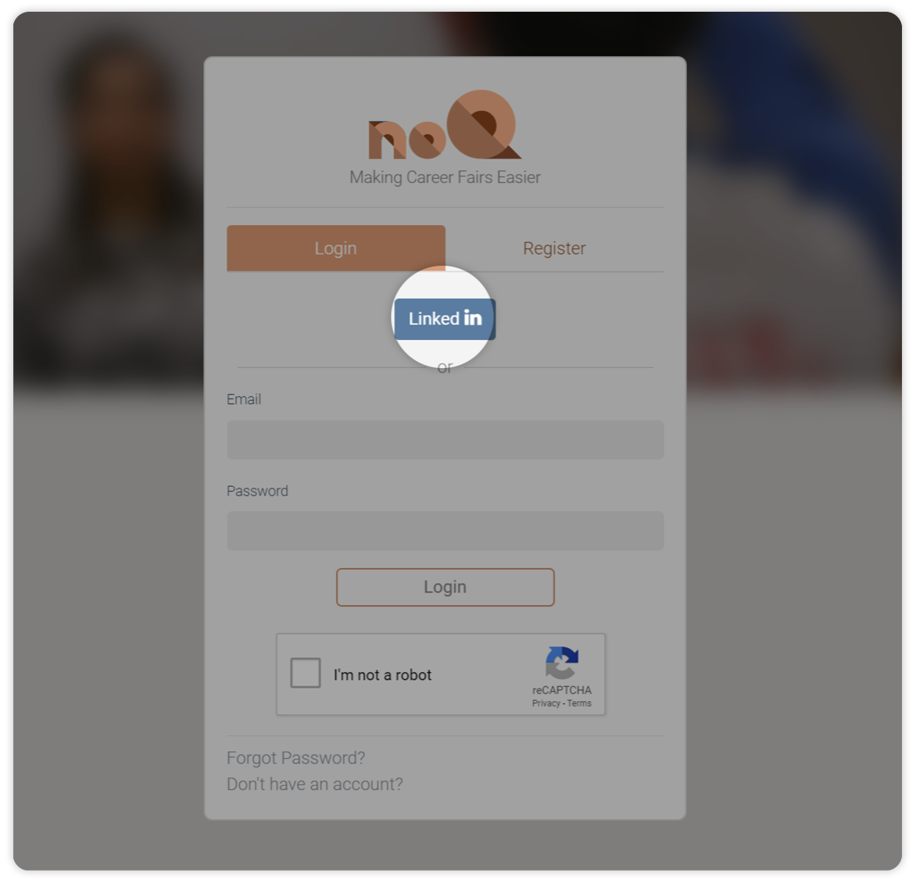

In the following page, sign in through your LinkedIn account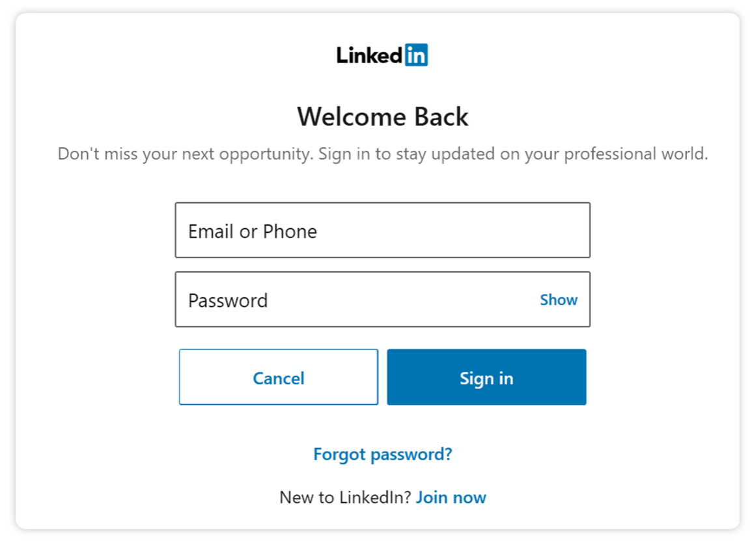

* 1. If you don’t have a LinkedIn account,
     1. click the “Register” tab

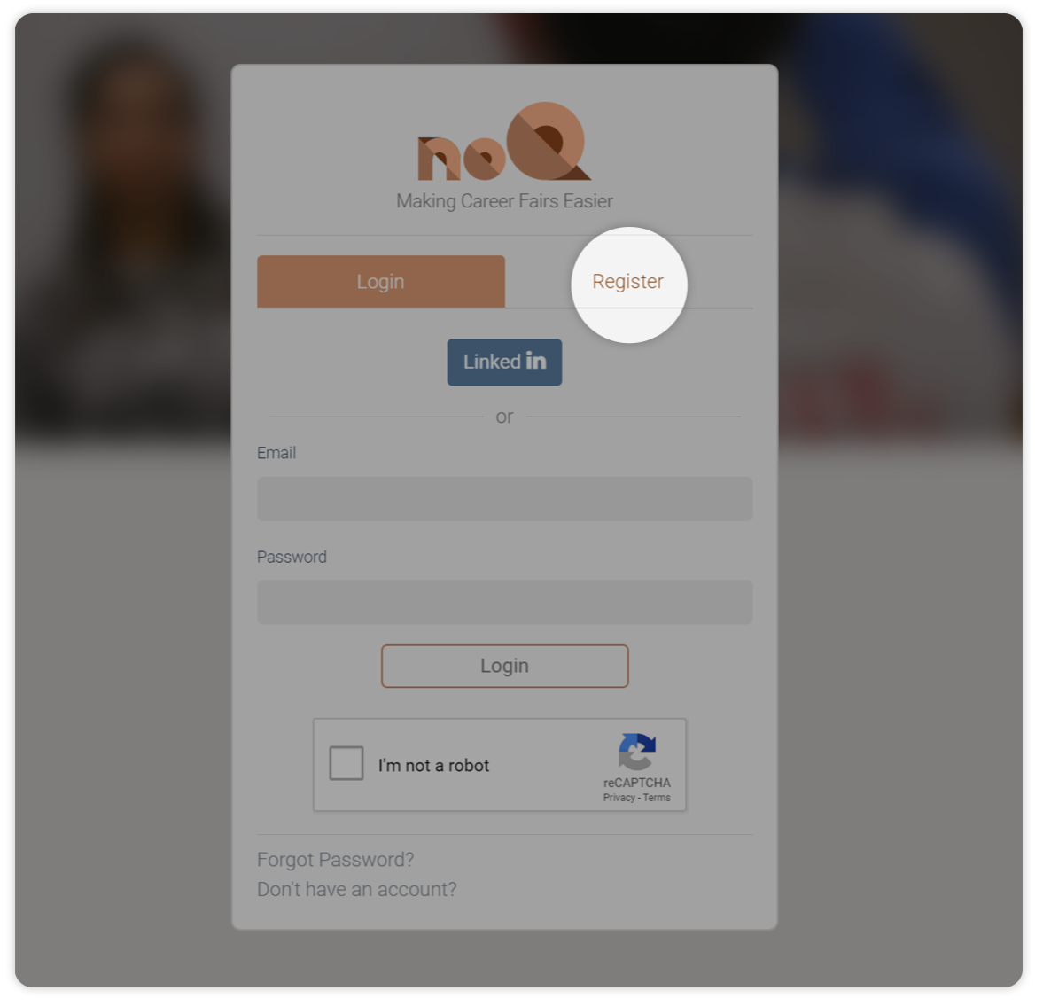

* + 1. fill out required information including your email, password (Must be at least 8 characters, have an uppercase letter and a special character), role (i.e. student or employer) and security question.

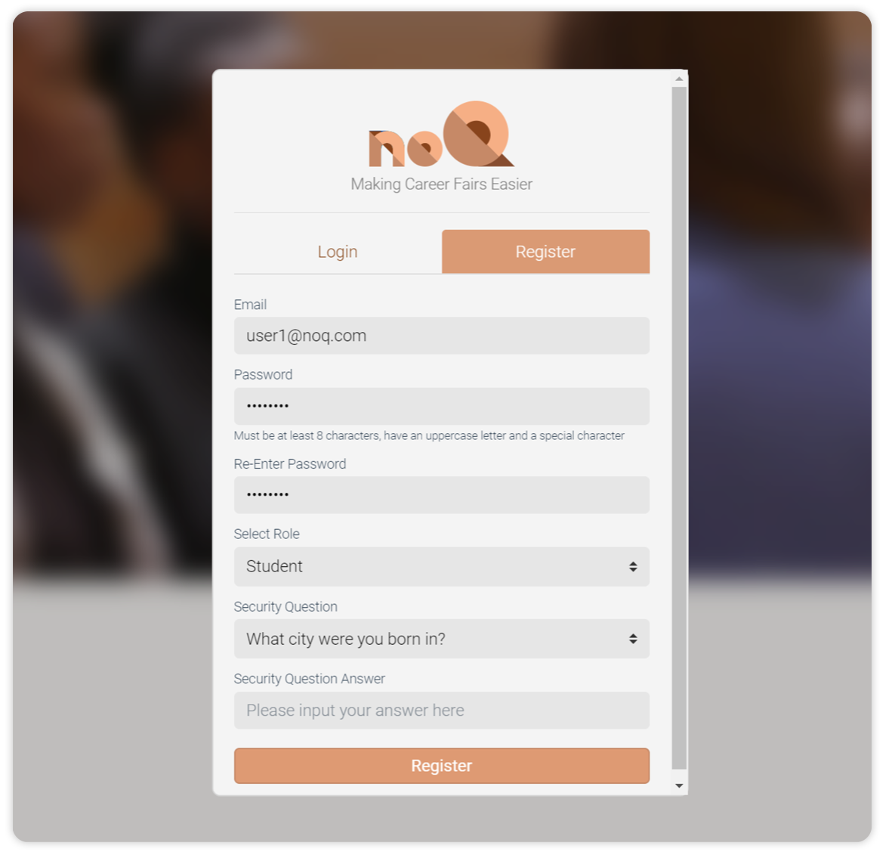

* + 1. After seeing a popup indicating you have been successfully registered, go to the inbox of your email used in the above step and find the verification email as the following image shows.

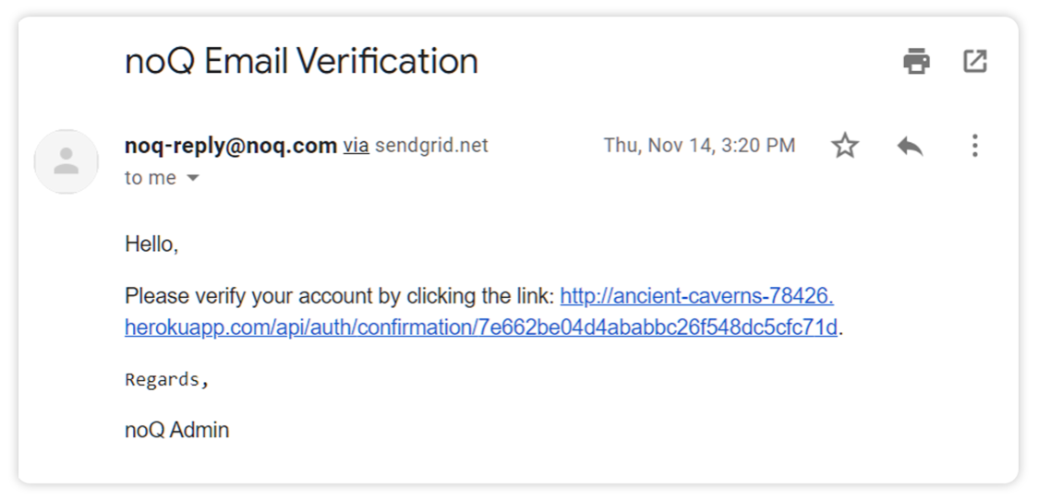

* + 1. Click on the link in the above email and you are done with registering.

1. **Login**

You can login through this page, either through your registered account or through LinkedIn.

1. If you registered with your LinkedIn account, click on the  button and sign in your LinkedIn account in the following OAuth page.
2. If you registered with your email, enter your email address and password used in the above step, then check the reCAPTCHA checkbox and click “Login” button. 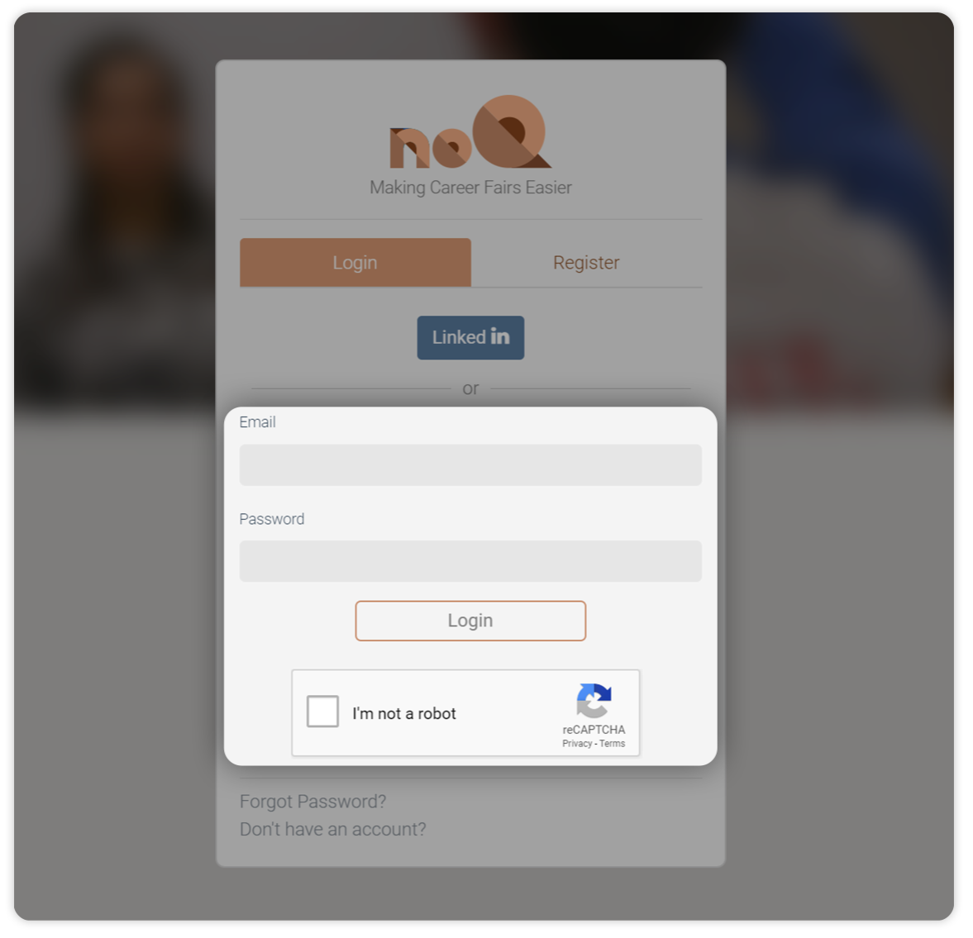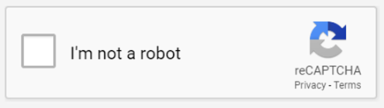
3. **Profile Builder**
   1. If you registered as an employer, fill out your personal information in the profile builder page.
   2. If you registered as a student, following the profile building wizard and complete your information. 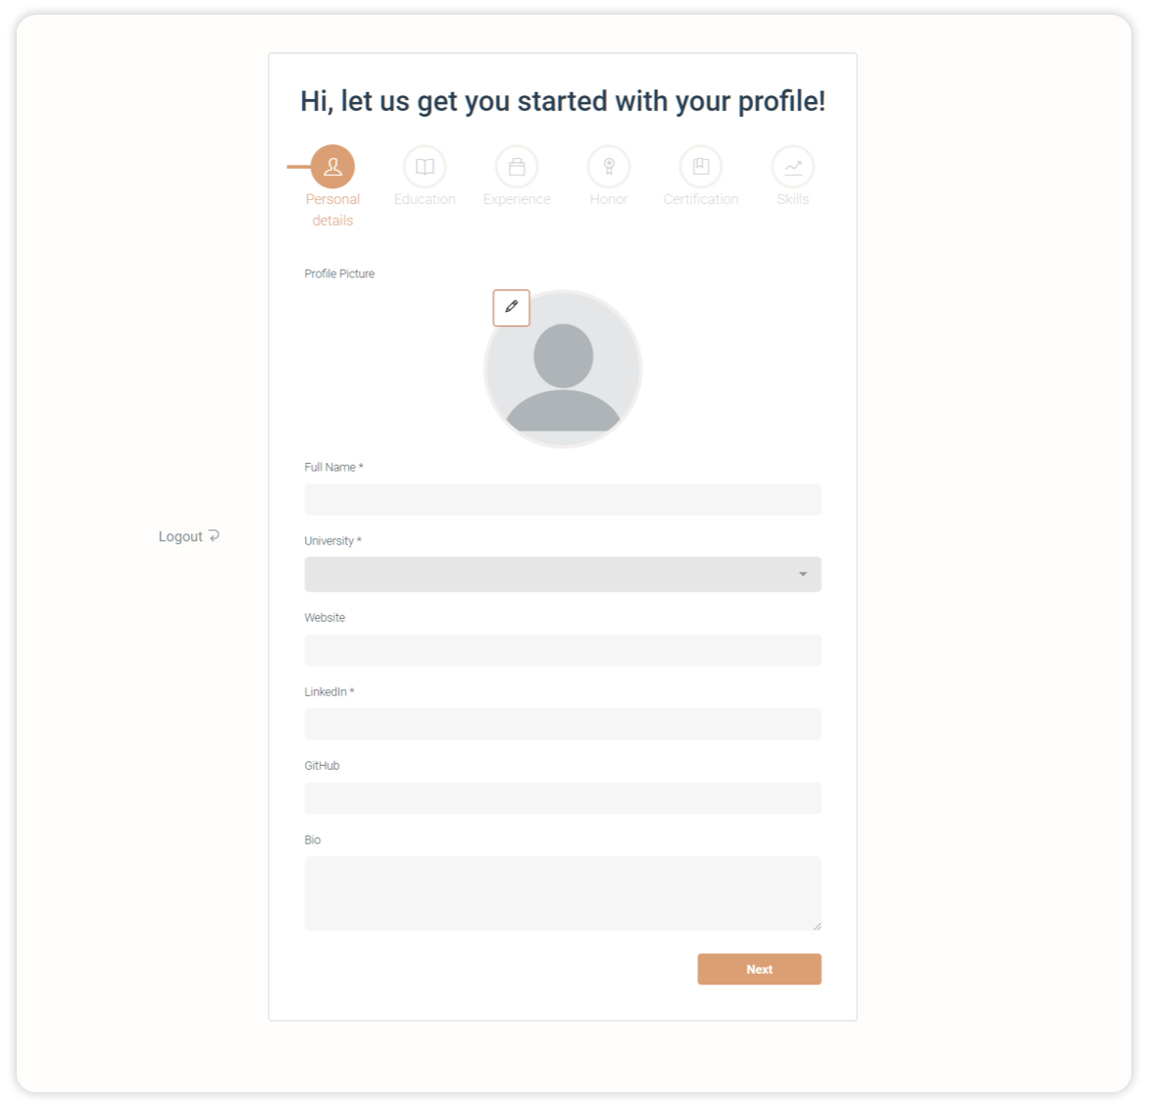
      1. When filling in the University box, input full or part of your current university’s name and choose the one matches in the option drop-down menu.

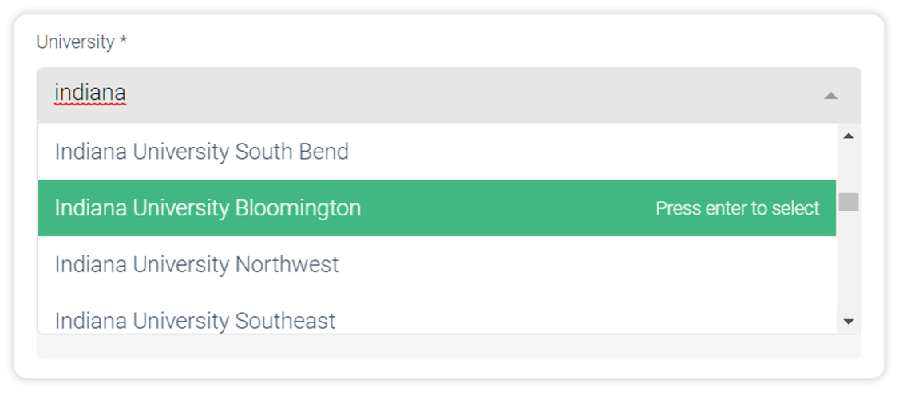

* + 1. After filing out one entry of Education/Experience/Honor/Certification, you can click on the add button and add another entry.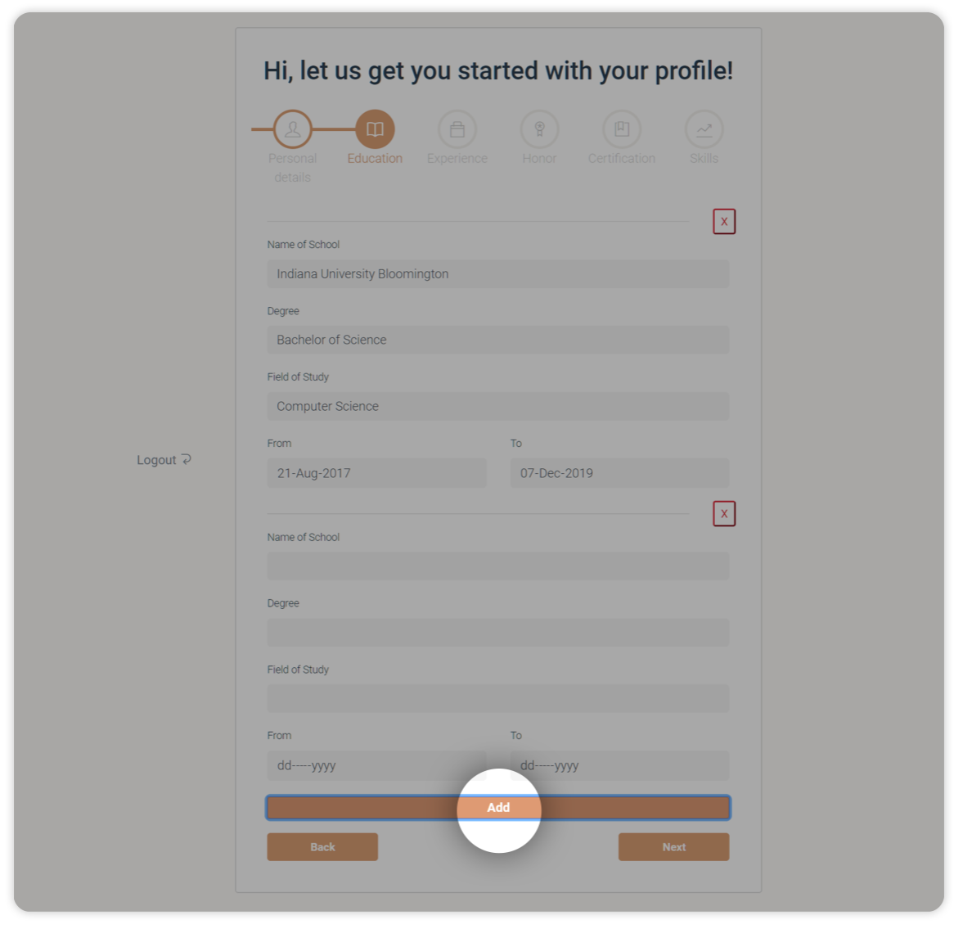
    2. For dates, you can either input them manually or click the down triangle to evoke a date picker.

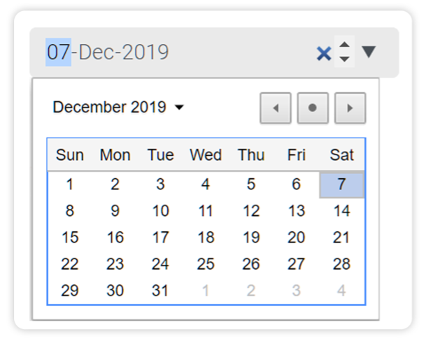

* + 1. In the “Skills” section, use the skill picker to search and select skills you have.

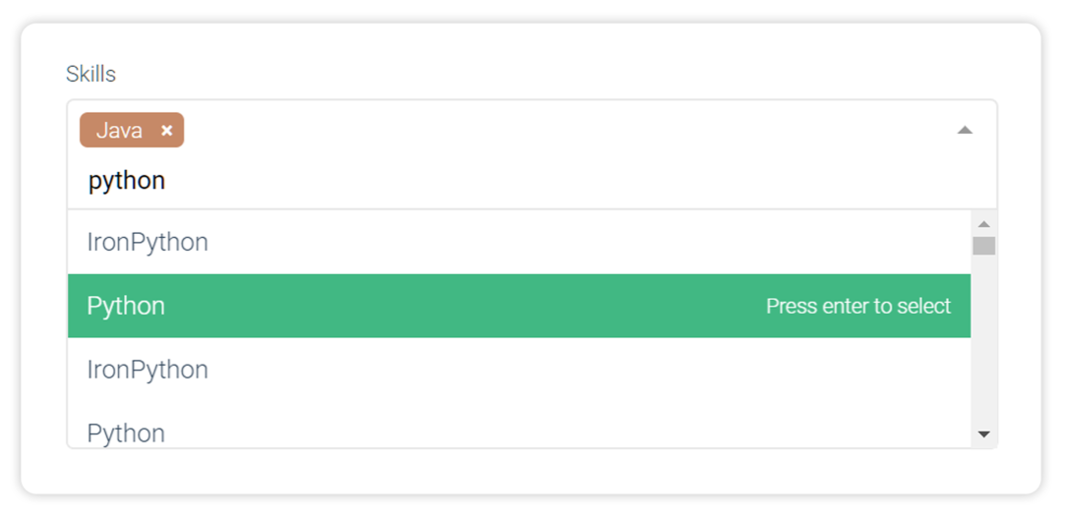

1. **Home Page**

The homepage allows students to view all the jobs for which they are qualified and apply or dismiss a certain job. It also allows employers to review applicants’ profile and choose to approve or reject their application.

* 1. **Student View**

If you are a student, your homepage will by default display all the jobs you are potentially qualified (i.e. jobs with skill requirements that partially or fully matches your skill set)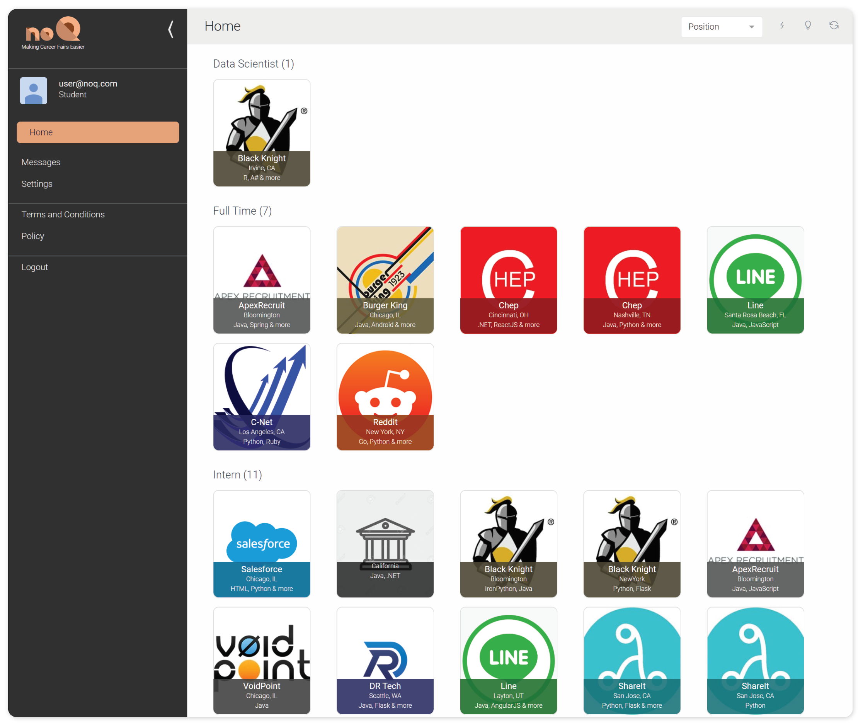

* + 1. **Job details**

To view details of a job, click on the job card and more information will popup.

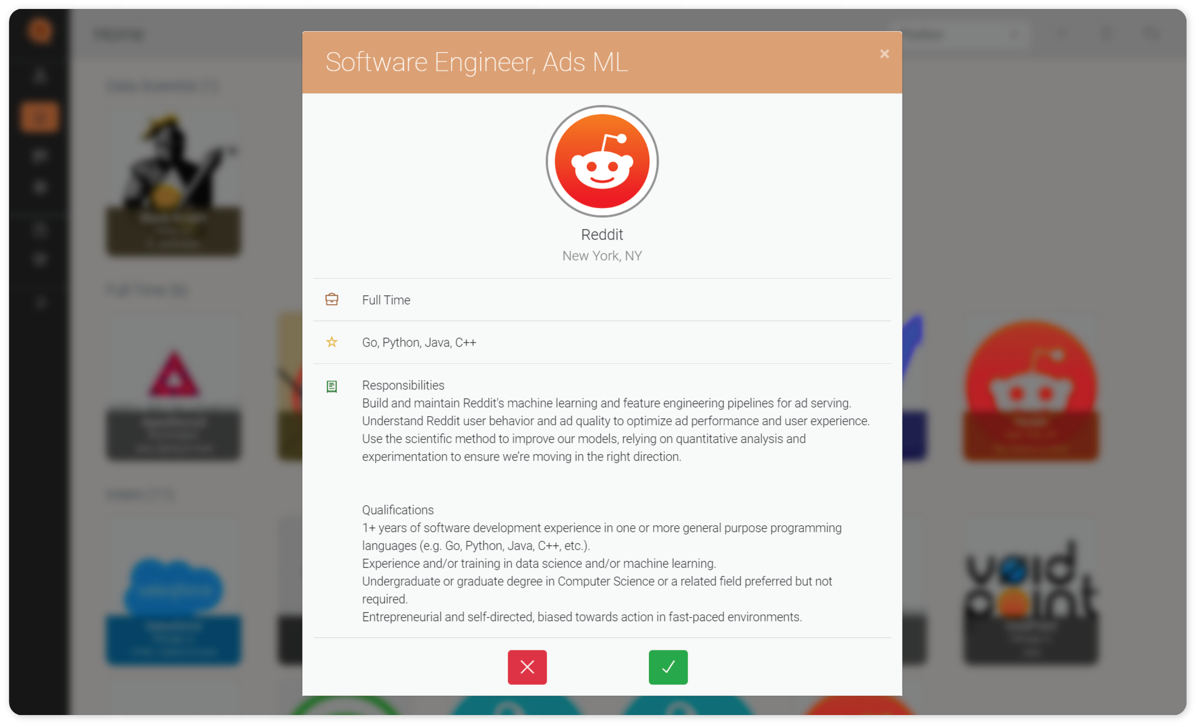

* + 1. **Apply / dismiss jobs**

To apply for a job or remove a job from your view, you can either hover over a job card, or open job details and then click on the corresponding button.

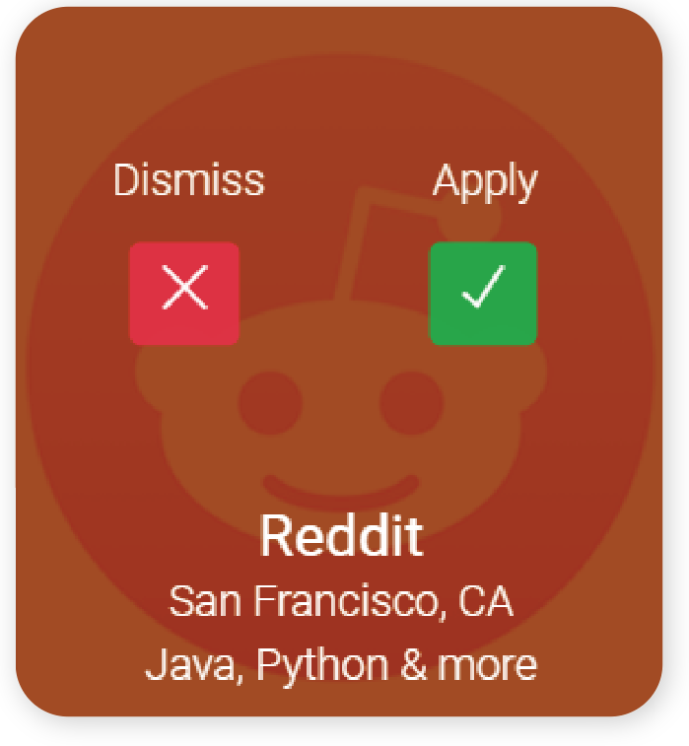

* + 1. **Filters**
       1. You can use the drop-down menu on the top-right to group job cards by their “Position”, “Location”, “Company” and “Skills”.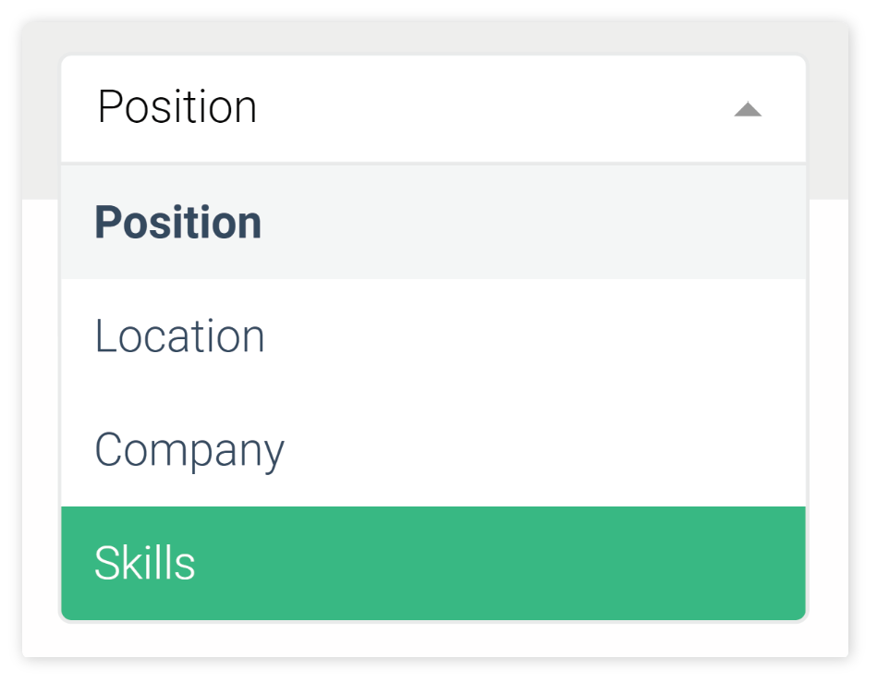
       2. You can also filter jobs by selecting the option “Skills” in the same drop-down menu and then in the evoked skill picker on the left, search or choose your skills to use as criteria for filtering jobs. 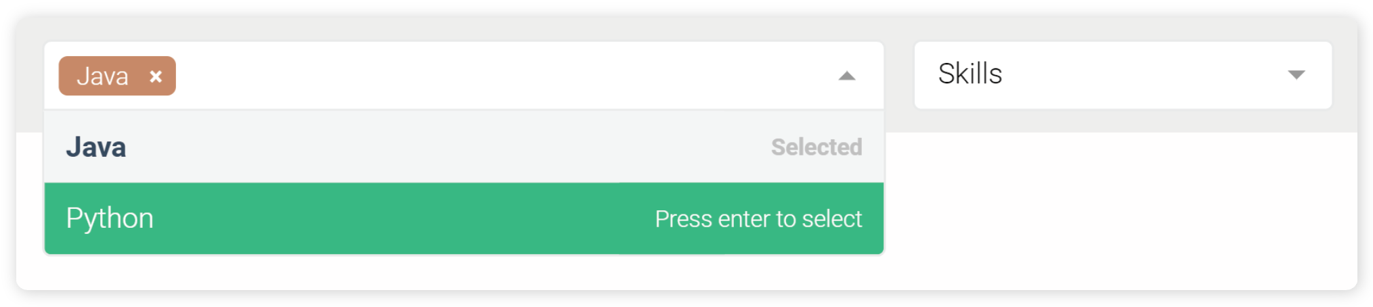
    2. **Recommendation System**

The recommendation system analyzes your past applications and skill set, then using them as basis, recommends positions for which you may be interested in.

To use this function, click on  button on the top-right and recommendations will show up similar to the following.

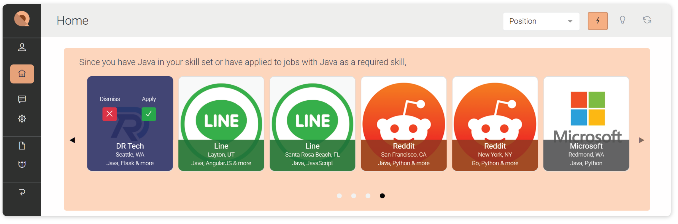

* + 1. **What-if Feature**

Jobs on the homepage are pre-filtered based on the skills you possess, however, you can also explore other available jobs with skill requirements that you don’t have at this moment. This is particularly useful to see what skills are currently “in-demand”.

To use this function, click on button on the top-right and then modify the skill tags by removing existing skills or search for new ones in the evoked skill picker.

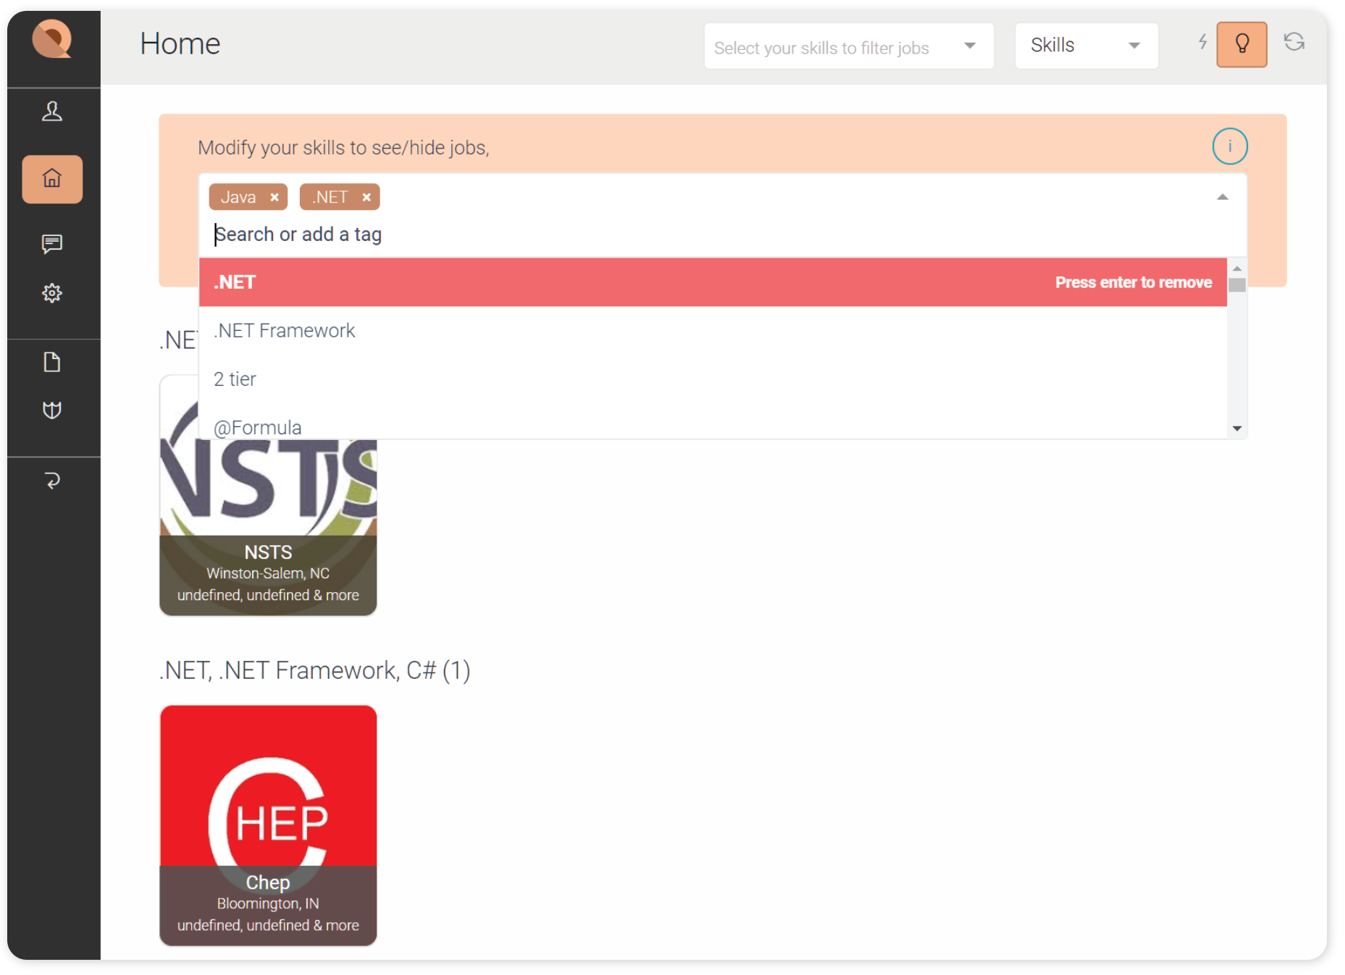

* 1. **Employer View**

If you are a recruiter, you can view users who’s applying for jobs you’ve posted. You can either accept or reject their applications by hovering on the user card and click the corresponding button, or you can click on the user card and view their detailed profiles.

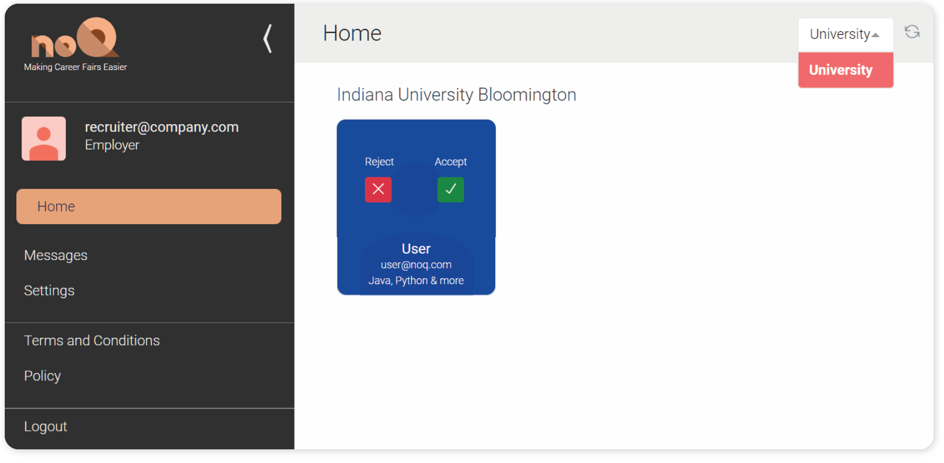

1. **Profile**

To access and modify your profile and related information, click on  button or your picture in the navigation bar on the left side of the page. 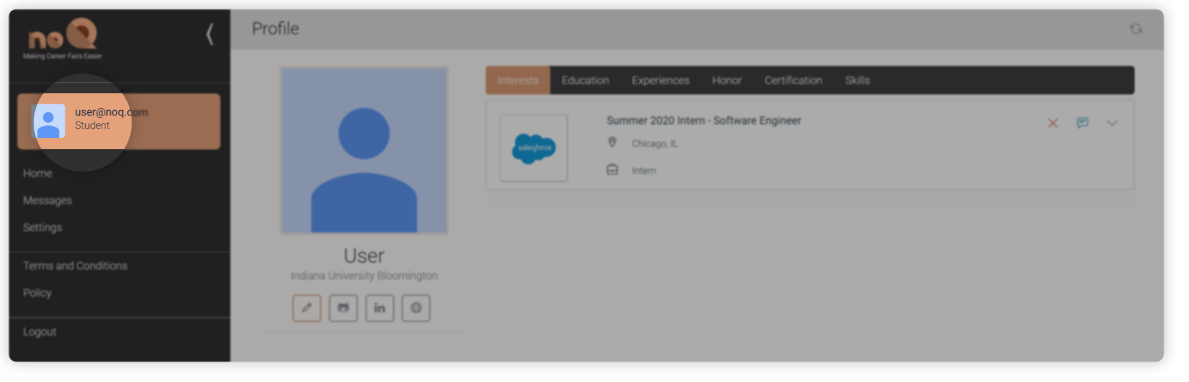

* 1. **Student View**
     1. **Edit Profile**

You can edit your basic information by clicking on the edit button under your picture and complete your profile in the “Edit Profile” popup.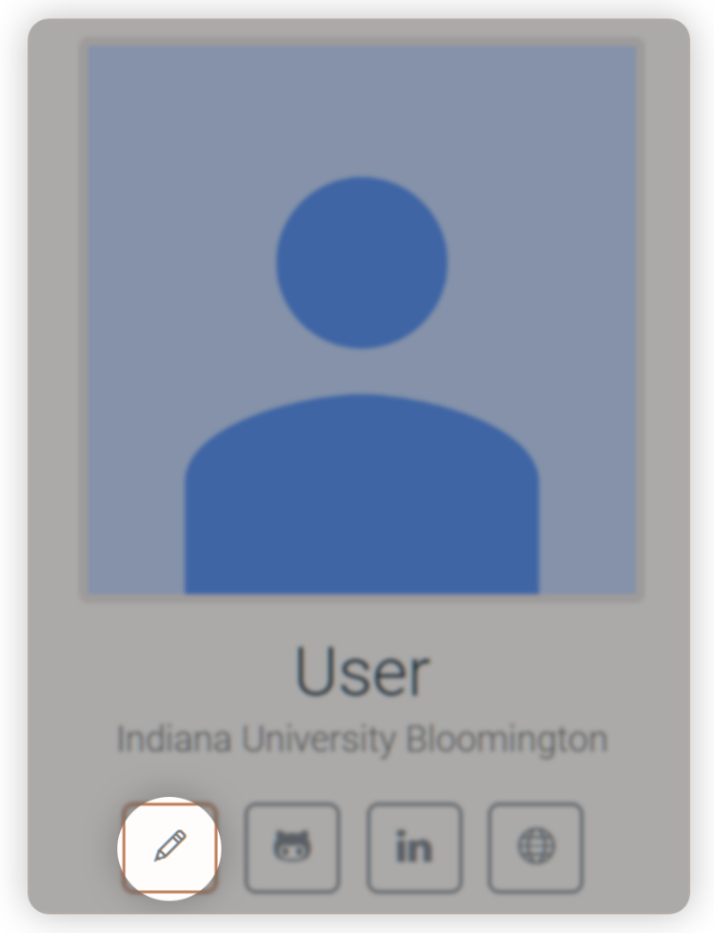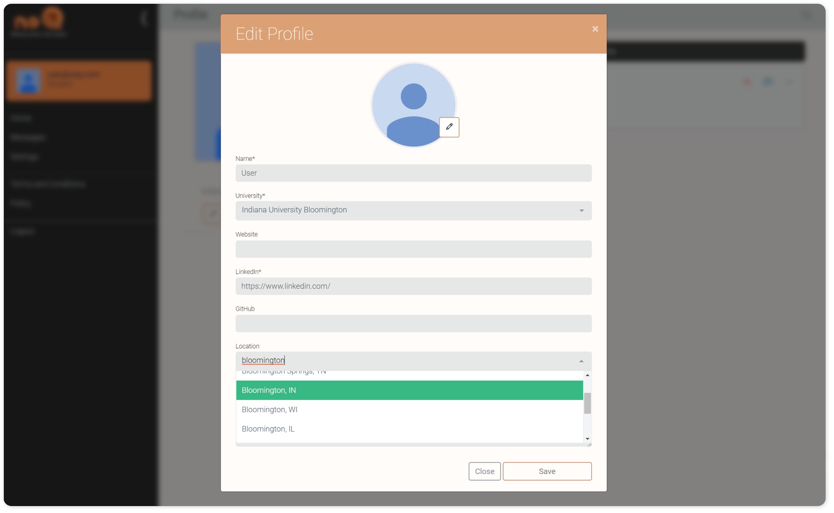

You can also refine your profile in “Education”, “Experience”, “Honor”, “Certification” and “Skills” tabs by clicking on the tab tags.

* + 1. **Interests**

In this tab, you can view all the jobs you’ve been accepted by recruiters and has moved on to the next step in the recruitment process.

You can use the three buttons on the top-right of a job card to reject a job, message the recruiter or expand details of a job.

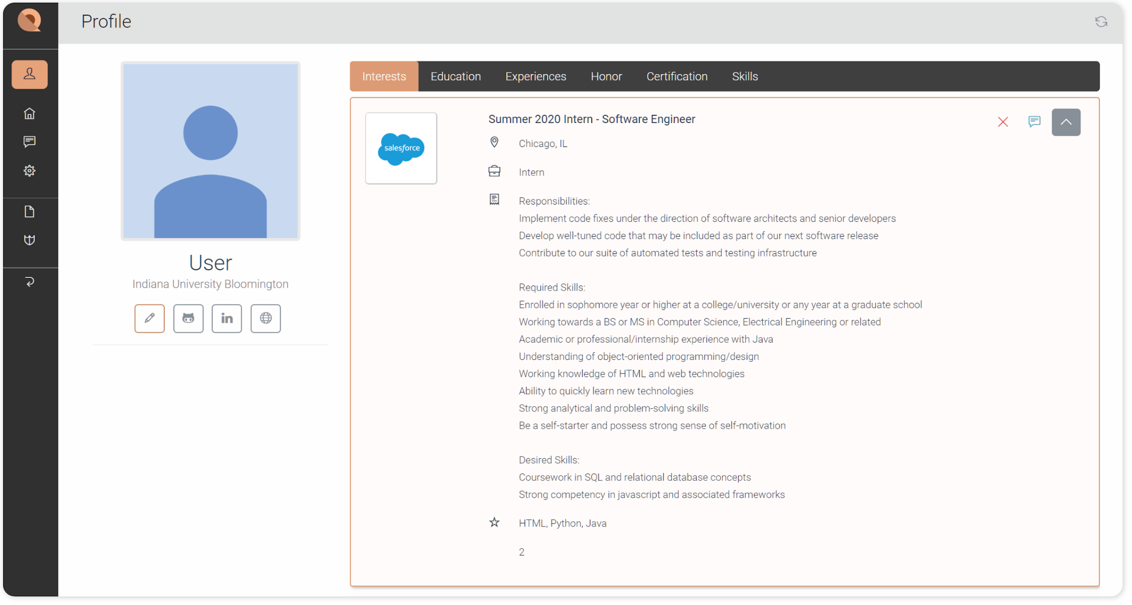

* 1. **Employer View**
     1. **Post/Edit Jobs**

You can post new jobs by clicking on “Post Job” button and then fill out required information.

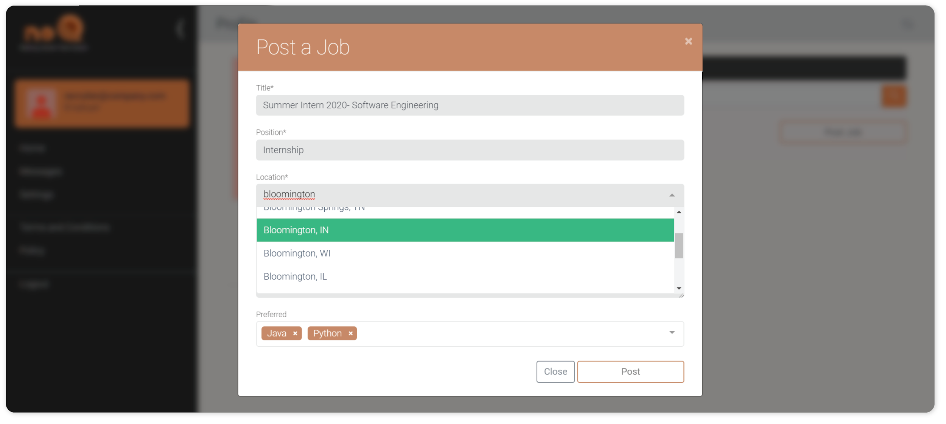

You can also click on the button to edit a posted job.

* + 1. **Search Jobs**

You can use the search bar to search for jobs with certain keywords.

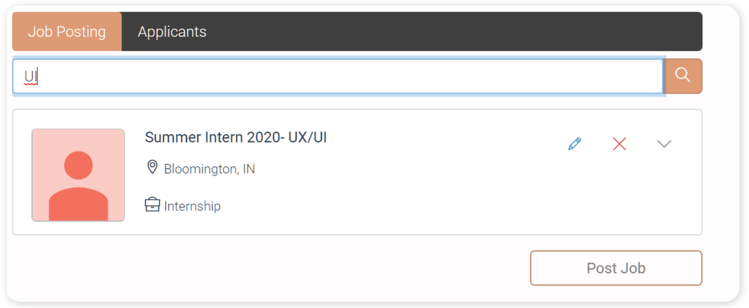

* + 1. **Manage received applications**

In the “Applicants” tab, you can view applicants’ profile by clicking on applicants’ names and the down arrow on the top-right to expand more information on the job they are applying for. You can also send messages to applicants in this page. You’ve received and send messages to other users.

1. **Messages**

In this page, you can review and send messages from and to other users. You can also check your contacts and start conversations with them.

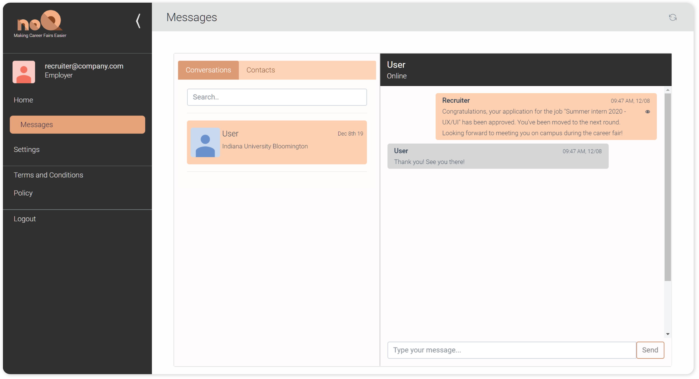

Remark: Aside form within the message tab itself, you can also start conversations from your profile page as mentioned above.

1. If you are a student, all recruiters from jobs that you have been accepted will be automatically added to your “Contacts” tab. You can click on their name and start conversations with them.

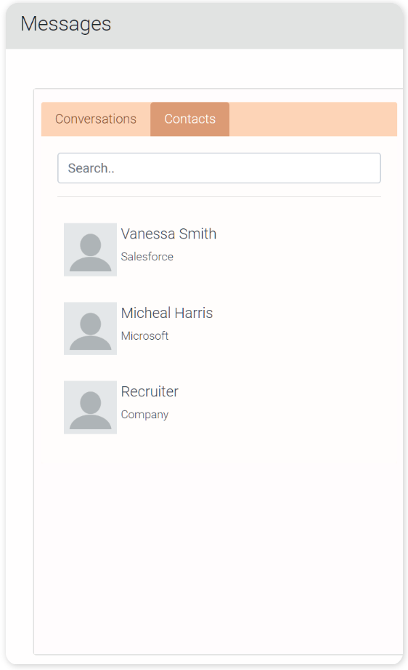

1. If you are an employer, all applicants from applications that you have approved will be automatically added to your “Contacts” tab. You can click on their name and start conversations with them.
2. **Change / forgot password**
3. To change your password, you can use the “Settings” tab in the navigation bar on the left side of the home page. Then follow the instruction and input your old and new password.

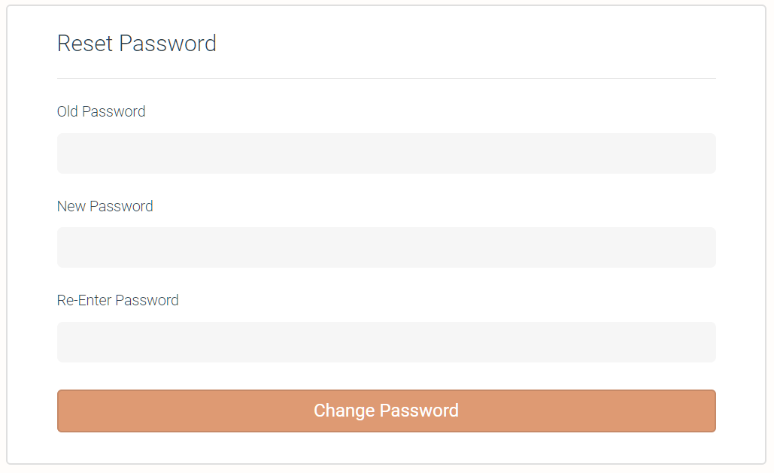

1. If you’ve forgotten your password, you can go to the “Login” page ( <https://noq-client.herokuapp.com/login>) and reset your password by clicking on the link "Forgot Password?". 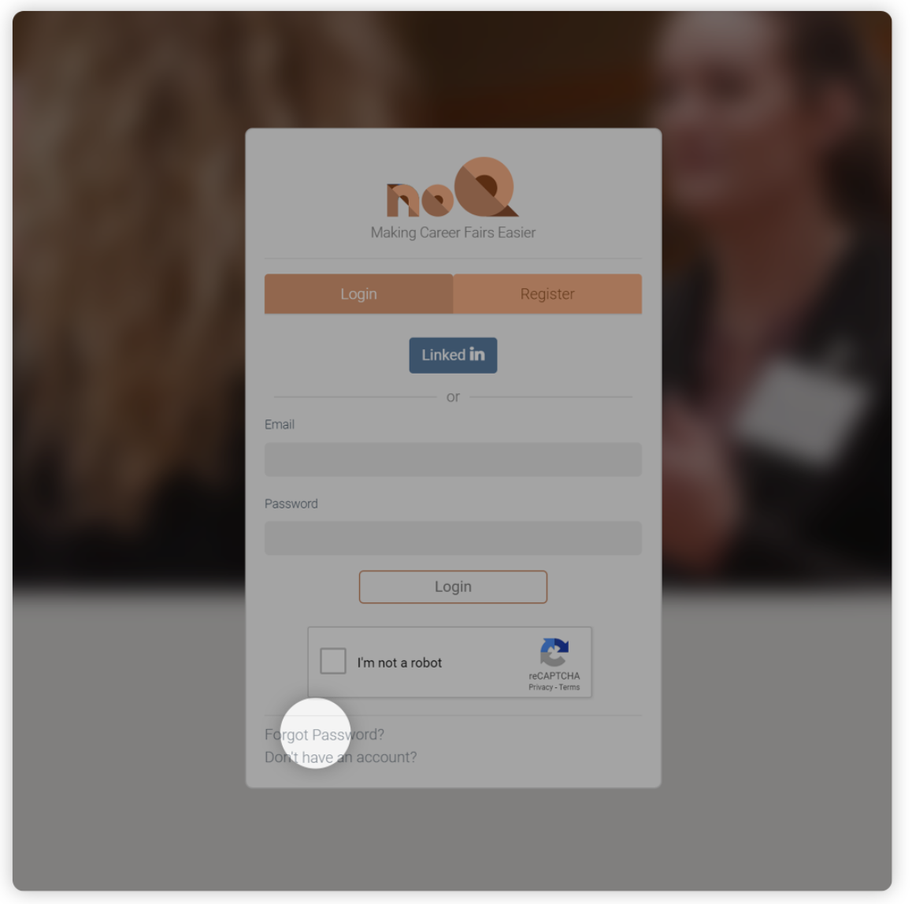

Then fill in the following form and verify the reCAPTCHA. A verification link will be sent to your email address and you can reset your password by clicking on the link.

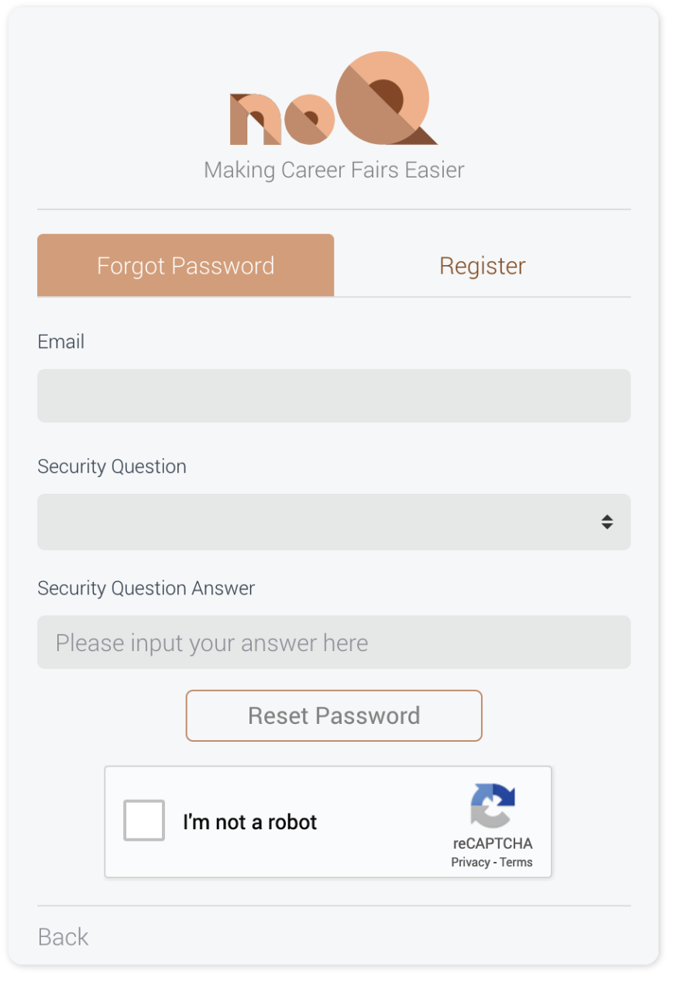

## 5. Known Defects

With multiple testing done on the functionalities and the UI, some defects are yet to be targeted. Although these defects exist, it does not hamper the functionality of the web application.

1. **Profile picture is sometimes not visible on the SideBar on login** - This is a problem of timing, as we have used an external service, imgur, to store our images. Which is why, at the time or render, the image isn’t present and therefore the application does not show the image. An easy fix to this would be to refresh the page once logged in.
2. **Some back-end routes are not protected** - Some of the back-end routes are not protected as a CORS error broke the functionality of those features. Not having this does not hamper the functionality.
3. **Some pages can be accessed although not logged in** - Pages like the Terms & Conditions and Policy can be accessed even though not logged in, which ends up displaying the sidebar with innvalid data.

## Revision History

|  |  |  |
| --- | --- | --- |
| Revision | Date | Change Description |
| Cole Norton | 12/3 | Part 1 and 5 |
| Hrishikesh Paul | 12/4 | Part 2 and 3 |
| Hrishikesh Paul | 12/5 | Part 4 |
| Hrishikesh Paul | 12/8 | Part 5 |
| Rui Zhang | 12/8 | Part 4 |
|  |  |  |
|  |  |  |
|  |  |  |
|  |  |  |

**Page Author/Creator:** [Adeel Bhutta](http://homes.soic.indiana.edu/aabhutta/)

**Last Modified:** 8/23/2016